Minh chứng

docker –version

docker run hello-world

docker pull nginx

docker images

docker run -d nginx



docker ps



docker ps -a



docker logs <container_id>

docker logs 7dca0f316289

docker exec -it <container_id> /bin/sh

docker exec -it 7dca0f316289 /bin/sh

docker stop <container_id>

docker stop 7dca0f316289

docker restart <container_id>

docker restart 7dca0f316289

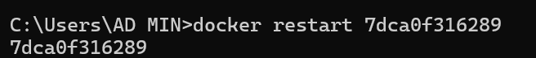

docker rm <container_id>

docker rm 7dca0f316289

docker container prune

docker rmi <image_id>

docker rmi 53a18edff809

docker image prune -a

docker run -d -p 8080:80 nginx

docker inspect <container_id>

docker inspect f639341708f3ce474e31effafeed156869d2b6973c730782a98b56040d0a0080

docker run -d -v mydata:/data nginx



docker volume ls

docker volume prune

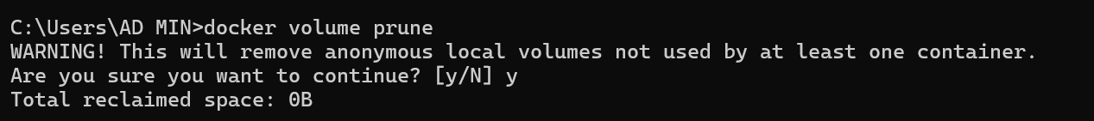

docker run -d --name my_nginx nginx

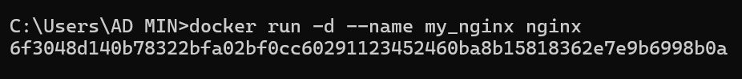

docker stats

docker network ls

docker network create my_network



docker run -d --network my_network --name my_container nginx



docker network connect my_network my_nginx

docker run -d -e MY_ENV=hello_world nginx



docker logs -f my_nginx

